

Guided Reading Skills
Inference

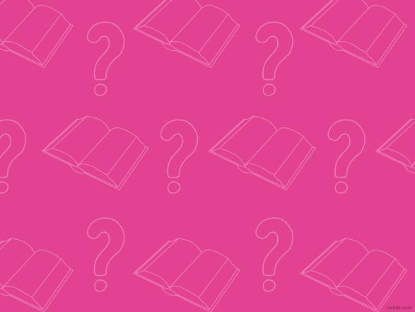



Inference
What is Inference?

Inferenc e is where we 'read between the lines' to gain a greater understanding of what we are looki ng at and to reac h logic al conclusions.


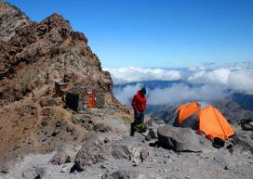
Inference
- Who is i n the picture?
- Is it col d or hot in the
mountains?
- How does th e
mountainee r feel?
- Why has the mountainee r chose n to climb to this location?

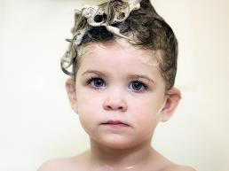
Inference
- What is happening in
this picture?
- How does th e child feel about it?
- Why isn’t the child
wearin g a top?


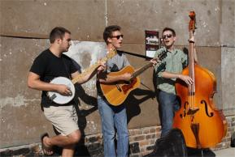
Inference
- Why are these men playing instruments outside?
- Why do two of the men have their mouths open?
- How does playing music make them feel?
- What sort of music are they playing?


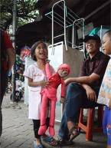
Inference
- What is the girl looking at?
- How does she feel about
what she can see?
- What is the weathe r like where the girl is?

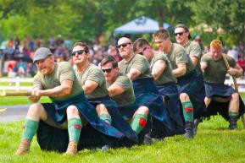
Inference
- What is happening
here?
- How can you tell that the men are puttin g in a lot of effort?
- Why does the man at the back only have one hand on the rope?
- How can you tell that these men belong to a club or group?
- What is the weathe r
like?


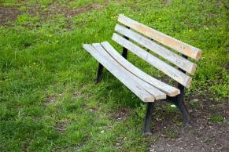
Inference
- Where is this bench?
- Who sits on it?
- Is this bench new or old?
- Does this benc h look comfortable?


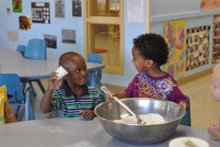
Inference
- What are these children doing?
- Whe re are they?
- How do the y feel about
what they are doing?
- What are they goi ng to
do next?
- Do these children know each other?

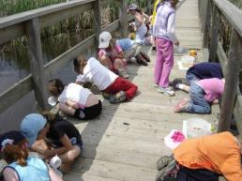
Inference
- Why are these children
on the floor?
- What are they looking at?
- Why are they wearing hats?
- Why do you think they are on a bridge ?


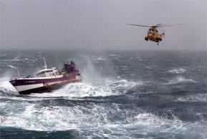
Inference
- Why is the helicopter flying towards the boat?
- Who do you thin k is in the helic opter?
- How might the people on the boat be fee ling?
- What impact is the weather having on this scene?


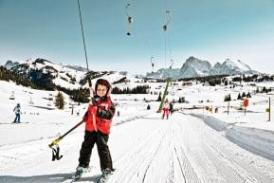
Inference
- What is this child doi ng?
- Do you think he has don e th is be fore ?
- Is this child at home or on holiday?
- Why is he wearing warm c lothes?

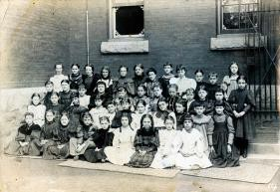
Inference
- Is this photograph
mode rn ?
- Whe re do you think these children are?
- How do the y feel about being there?


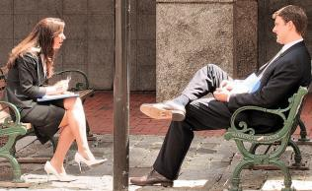
Inference
- What do you think these people are talking about?
- Are they both feeling the same way?
- Whi ch person is the most relaxed?
- How can you tell?



Inference
- Who is i n the picture?
- Is it col d or hot in the
mountains?
- How does th e
mountainee r feel?
- Why has the mountainee r chose n to climb to this location?


Inference
If your te ac her is not at school today, can you infer that:

…your teacher is ne ver going to return?
…there will be no le ssons at school today?
…you will not be given any h omework?
…your teacher is sick or at a me etin g?


Inference
Can you read the sentence below and find the correct inference?

Can you infer that:

…Tom’s car was a Rolls Royce?
…someone had cle an ed Tom’s car as a surpri se ?
…Tom’s car was red?
…Tom had never cleaned his car before?
Tom coul dn’t believe his eyes! His car was
cleaner than he had ever seen it!


Inference
Can you read the sentence be low and find the correct infe re nce?

Can you infer that:

…the c hildre n we re bored?
…it was winter time?
…the c hildre n loved f ire works?
…it was the first time the c hildren had seen fireworks?
Boom! Fizz! Anothe r one explode d over the children’s heads as they grinned and yelled in e xcitement.


Inference
Can you read the following passage and answer the questions?

- Why di d the baby throw th e ve getables onto the floor?
- Why di d mum shout at the dog?
- How did the baby feel when the vegetable s were licke d off the floor?
- How do you know?
My b ab y sister picked up her vegetab les and – one by o ne – threw them off her highchair and onto t he floor. She kicked o ut her legs and g iggled as they were q uickly licked off t he floor. When Mum cam e b ack int o the ro om, she shouted at the dog to go away.


Inference
Can you read the following passage and answer the questions?

- What was Will trying to get to work? How do you know?
- How did Will fee l whe n the screen went black?
- How long do you think Will had be en sitting there?
- What might Will h ave been doing before this happened?
Will sighed and clicked the mouse again. It still wasn’ t work ing. Then suddenly the screen went b lack. “ Oh no!” wailed Will. “It’s all go ne! I haven’t g ot time to st art again!”


Inference
Can you read the following passage and answer the questions?

- What did Maisi e see outside her bedroom window?
- Why was she going to have porridge for breakfast?
- How did Maisie fee l about th ere being no school today?
When Maisie drew her curtains t hat mo rning, she smiled and wrap ped her arms around herself. There wo uld b e no scho ol today, that ’s for sure. She would get wrapp ed up and dig her sledge out of the garag e. Then she would spend the rest of the day wrapped in a b lanket. “Porridg e fo r breakfast , I think!” she said.


Inference
Can you read the following passage and answer the questions?

- How did the writer feel when the post arrive d?
- Was the write r expecting thi s letter?
- How do you know the letter is important?
The letter b ox bang ed and I ran quickly to the door. With shaking hands, I slowly p icked up the lett ers o ff the floo r. A bill. A postcard. And then finally the let ter I had been waiting for. I stared at t he heavy cream envelop e and the handwritt en address. I ho ped for goo d news.


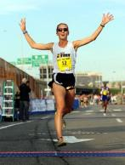
Inference
- What can you infer from th is pic ture?
- What makes you think that?


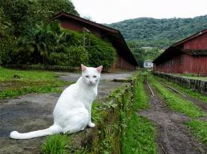
Inference
- What can you infer from th is pic ture?
- What make s you think that?

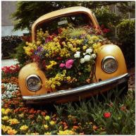
Inference
- What can you infer
from th is pic ture?
- What make s you think that?


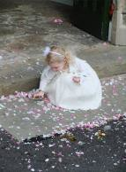
Inference
- What can you infer from th is pic ture?
- What makes you think that?


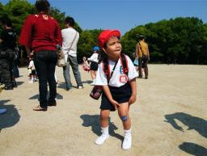
Inference
- What can you infer from th is pic ture?
- What make s you think that?

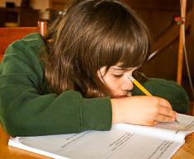
Inference
- What can you infer
from th is pic ture?
- What make s you think that?


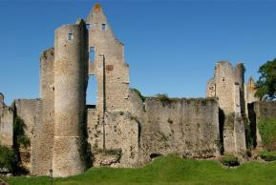
Inference
- What can you infer from th is pic ture?
- What makes you think that?


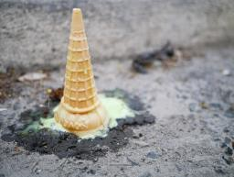
Inference
- What can you infer from th is pic ture?
- What make s you think that?



